Policy Formatting Guidelines for Services

- General Formatting Guidelines
  - Formatting in this context refers to the method of organising the text in a policy document.
  - There is no one correct way to format a policy; use the method that works best for your service.
  - The purpose of formatting is to visually organise and structure the content of a policy so that:
    - Information in the policy is easy to access for those reading it
    - There is clarity, structure and organisation of the information in the document
  - This can be done through:
    - Using clear headings as signposts throughout the document
    - Using a consistent format throughout the individual document as outlined below, and across the service’s policy library
  - The guidelines below are based on Microsoft Word 2003. For services using a different version of Word, there may be some variation.
  - Please note that this is a brief guide to some formatting issues that may be encountered when adapting Ana Liffey Drug Project (ALDP) policies. Basic word processing skills are needed, and reference to other more comprehensive resources (see section 8) is encouraged to effectively adapt and format new policy documents.

- Font Colours in Ana Liffey Drug Project Policies
  - ALDP uses different three different font colours in our templates to guide tailoring of the templates to individual services
  - Each font colour communicates a different instruction to the reader:
    - Font in blue refers to
      - Requirements in relation to the policy or area of service provision
      - Other information which ALDP wishes to communicate directly with services in our own voice
    - Font in red must be changed by the organisation to reflect local information and practice
    - Font in black should be reviewed and changed to suit the service if needed.

- Font Style and Size
  - The font used by Ana Liffey Drug Project is ‘corbel’.
  - For section headings, text is ‘bold’ and size 12.
  - For the body text size is 10.

- Header
  - A header is the title bar that appears at the top of each page which is separate from the text. It includes the project name and the name of the policy
  - Each service should put the name of their service into the header. This can be done by
    - Double clicking on the green section of the header box and writing the service’s name in the green box.
    - Once done on one page the header on every page will change
  - To insert a new header box:
    - ALDP do not put the header on the cover page of the policy. To do this:
      - Go to File
      - Choose Page Setup from the drop down menu
      - Choose the Layout tab
      - In "Headers and Footers" click on different first page.
    - To create the header for the rest of the document:
      - Copy the cell below

Project Name | Name of policy

      - Go into the View menu
      - Click on “Header and Footer”.
      - Paste the copied cells into the header box on the second page of the document (not into the first page)
      - Click ‘close’ in the header box and the header should appear in every page.

- Formatting Copied & Pasted Text from Another Document
  - Where a large chunk of text is copied from another document such as a pre-existing policy or service website, the formatting is generally copied too. This may or may not cause some difficulties in the new document. If this occurs:
    - Highlight the text that you pasted into the policy
    - Go to ‘Format’
    - Click on ‘Styles and Formatting’
    - Click on ‘Clear Formatting’ from the list
    - This will remove any unwanted formatting. You can then change it to the font / size required

- Numbering
  - Policies follow a numbered outline. This is useful in that it enables all users to access information quickly and efficiently.
  - It is achieved through the ‘Bullets and Numbering’ section that appears when you click ‘Format’
  - Click on the third tab called ‘Outline Numbered’.
  - Double Click on the tab highlighted below
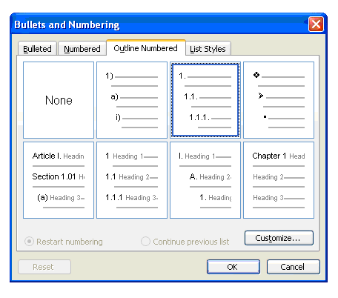
  - In the document to skip to the next number in a sequence of bullet points (e.g. from 1 to 2), press ‘enter’
  - To create sub-points (e.g. to go from 1 to 1.1), use the ‘Increase indent’ button on the formatting toolbar (see image below)
  - To move back out from a sub-point to the main list of points, use the ‘Decrease indent’ button
  - If these buttons are not visible, look in ‘View’, then ‘Toolbars’ and ensure ‘Formatting’ is checked.

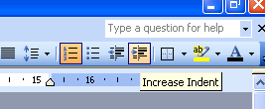

Example
    - Press enter (this creates a new line (6.8.2)

    - Press enter and ‘increase indent’ (This creates a new line and moves from 6.8.3 to 6.8.3.1)
      - Press enter and ‘decrease indent’ (This creates a new line and moves you back to 6.8.4)

  - If you miss a line and the bullets seem to go back to ‘1’ again, there are a few ways to get back into sequence
    - You can delete the spaces between the text and the previous bullet until your new line of text follows on directly from your last line of text and press enter. This will get you back into sequence.
    - You can go back into your ‘Bullets and Number’ tab and check the button at the bottom which states ‘Continue Previous List’

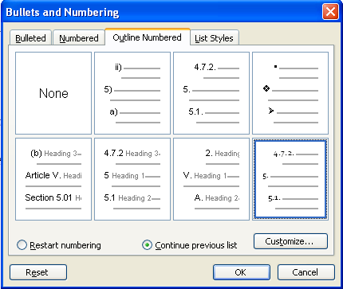

- Track Changes
  - This function can be used to document changes made to policies so that both the original and the changed text are visible. This may be useful to show changes to others that have been made or changes being proposed.
  - Track changes can be enabled by going to “Tools” and selecting the “Track Changes” option. Alternatively, pressing the Control, Shift and E keys at the same time will enable track changes.
  - Occasionally when editing a document ‘Tracked Changes’ appear as comments on the right hand margin (see example below) or the text may appear in a different colour with a line under it.
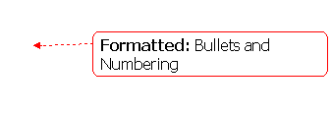
  - Colleagues can then right click on the arrow and / or the underlined text and decide to accept or reject the change
  - To turn off the ‘Track Change’ tool go into ‘Tools’, and click ‘Track Changes’

- Resources
  - Microsoft Support: http://support.microsoft.com/?ln=en-ie has a useful search function.
  - Microsoft Word helper: http://office.microsoft.com/en-us/word-help/
  - The Help menu in MS Word is also a useful tool

